ID: 18268 NAME: Daniel Pratama

wells international college

User experience assessmet

|  |  |  |  |
| --- | --- | --- | --- |
| Name of Student | Daniel Pratama | ID | 18268 |

**Assessment 1 – Project**

Contents

Project Background 2

Café Story 2

Café Statistic before 2020 Covid-19 pandemic 3

Task 1 3

Task 2 3

Task 3 4

Task 4 5

Task 5 5

Task 6 5

Task 7 6

Task 8 7

Index 7

***Instructions:***

The trainer may decide whether this will be an individual or group assessment.

In this project, you will need to perform various tasks related to interface design, user research, wireframing and prototyping for a web application according to the requirement specified in the project background.

***Duration:***

Trainer will set the duration of the assessment.

Please refer my web design for this assessment:

Sample Site: (Please note the site must show your student id and your name.)

<https://danielpratama18.github.io/Ux012023by18268/>

# Project Background

You are approached by the WIC Café to design a café website for their business. You can refer to denbisco.com or noccoffeeco.com as examples of café sites.

Here you could use any topic to develop your project! Here my example only shows web structure!

## Café Story

WIC Coffee’s inception was a childhood outdoor adventure amongst grandma's many fruit trees including the big-leafed and lofty liberica coffee. The cherries’ hues of red, the otherworldly complexion of the green beans, and the aroma of the roast are to be recalled much later through an espresso machine, a grinder, a modified popcorn machine and an insatiable desire to make better coffee.

A special tamper here, a special temperature probe there, joined the growing collection of equipment dedicated to the pursuit of great coffee. A small commercial roaster followed. Then a tiny café tucked away in a quaint suburb became the next outlet for the obsession. The few handfuls of beans at the beginning have turned into a hill of green.

But even great coffee can be made better.

So, the madness grows, along with the roaster, the coffee machine, Coffee Lover in Ultimo, WIC Cafe by Coffee Lover in World Square Complex, Micro cart Coffee in Crown Casino.

While we like to work quietly to the tune of our own roasting drums, we also garnered the Australian Barista

Champion title, Coffee Art Champion title, the NSW Championship titles, the inaugural Asia Pacific Cupping Champion title, the Coffee Guide Sydney "Haven Shot" plus 5 "coffee beans" Award in 2018 and 2019 and the "Best Coffee" award in the SMH Good Cafe Guide in 2017, 2018 & 2019.

The café is use to opened and served customer on the premises. During the Covid-19 pandemic, customers behaviour has been changed, sale record indicates that 60% sale dropping due to the restriction and social distancing regulation.

## Café Statistic before 2020 Covid-19 pandemic

Customer Age range

* 10-15 years 5%
* 16-25 years 20%
* 26-35 years 30%
* 36-45 years 30%
* Over 45 15%

Sale Record: average of 2875 cups per weeks Signature Coffee bean:

* Kenya Arabica beans
* Indonesia Arabica beans

Open Hours:

* Monday - Wednesday & Friday 7:00am - 5:15pm
* Thursday 7:00am - 6:15pm
* Saturday 8:00am - 4:15pm
* Sunday 10:00am - 2:45pm

**Your tasks:**

# Task 1

Analyse business requirement/needs and Identify business problem and goal.

Problems

* Decline on customer number.
* Strictly on social distancing regulation
* Need to design a website for their cafe business.
* Need to capture customer data, such as age range, sale record, and signature coffee beans.
* Need to advertise open hours.

Needs

* Business website
* Loss of sales due to Covid-19 restrictions and social distancing regulations

Goals

* WIC Café website will increase the revenue by open the new channel for online order and delivery.
* Increase sales by utilizing a website to reach more customers and advertise the cafe's offerings.
* Collect customer data to understand customer needs and preferences better.
* Increase customer engagement by providing an easy-to-use website.
* Increase brand recognition by creating a website that is unique and memorable.

<https://danielpratama18.github.io/Ux012023by18268/#taskone>

# 

# Task 2

Select target user and develop 2 personas.

* Local people
* Office staff near the location
* Tourist or Traveller

Any people come to joy our nice coffee or good food. Could be assess any time online.

<https://danielpratama18.github.io/Ux012023by18268/#tasktwo>

# Table Description automatically generatedTask 3

1. Develop WIC Café wireframe and present to trainer. The wireframe has to illustrate all pages for the café website. Website specification as following:

4 web pages

* + Home
  + About us
  + Product
  + Contact us

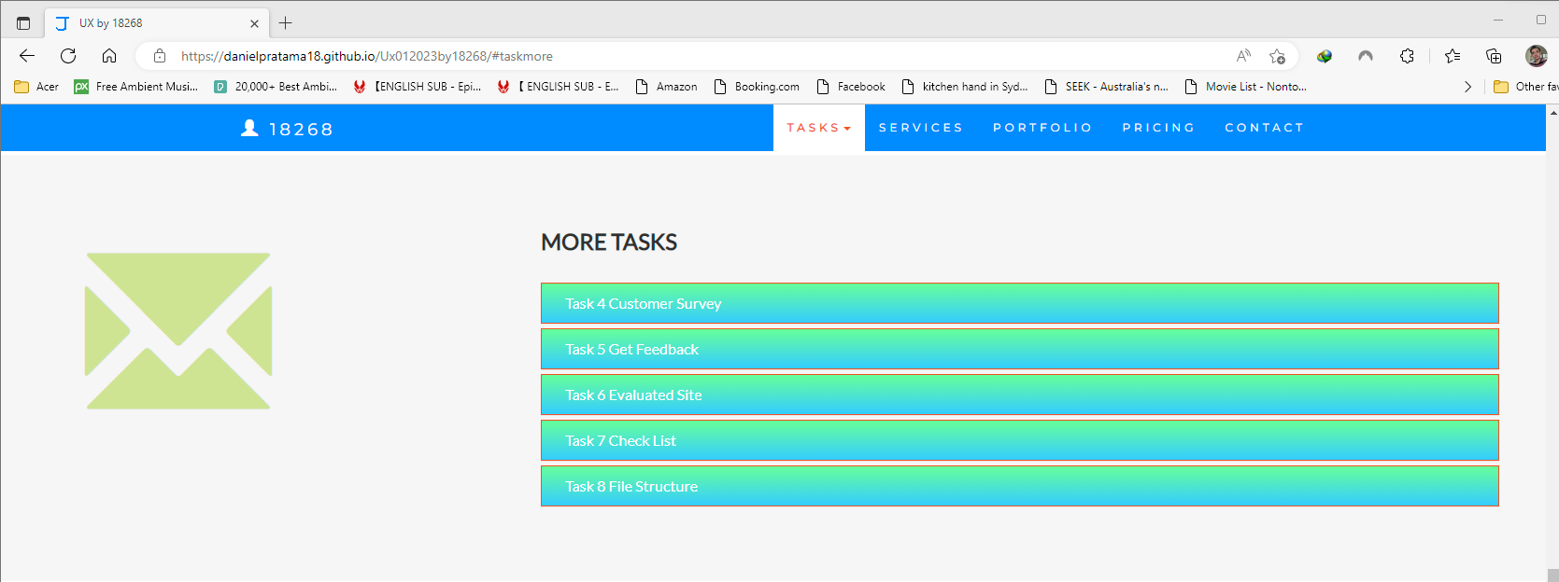

1. Amended the design from trainer feedback (if required). Then develop a digital prototype.

I help my friend to make decision: open video shop or not. So I design feedback form.

It could be access from: <https://docs.google.com/forms/d/e/1FAIpQLSccE14kghq9FFHNJvmQy55ac2vKl4xb5rzWmmlieJpFT2DsQw/viewform>

# Task 4

Develop a usability testing plan.

I will use Google Form to get user feedback.

Here I will do later.

I used right form to get data from local people.

After make survey, I could get Excel like below:

Here just example.

You need design how to solve this problem.

Please refer:

<https://www.youtube.com/watch?v=BtoOHhA3aPQ>

# Task 5

Conduct usability with at least 6 target users and gather the result.

Google form could help me to show all the user feedback.

# 

# Task 6

1. Evaluate test result and prepare the summary.

* We will review all feedback data and try to make our business getting better.
* Overall, the user experiences from the "WIC Coffee" website were excellent with most users finding the website easy to navigate, the content providing the necessary information, and the website design appearing aesthetically pleasing. All users would recommend the website to others.

1. Highlight an abnormal value and discuss possible reason.

* Because we just open our shop, more need to be done late.
* The abnormal value found in the test results was a "Fair" rating. The user may have been dissatisfied with the website's navigation, content, and/or design, or they may have encountered an issue that prevented them from enjoying the website. It's possible that the user's device or browser was not compatible with the website, or that the website was experiencing technical difficulties at the time.

1. Summary change or improvement will be applied on the prototype and get approve from your trainer.

* Make the web site getting better. Add more online sell and quick to response to our customers.
* Based on the test results, it is recommended that the website be improved in terms of its navigation, content, and design to ensure that all users have an excellent experience. Additionally, the website should be tested on different devices and browsers to ensure compatibility and ensure that technical difficulties do not arise. These changes should be implemented and approved by the trainer before the website can go live.

# Task 7

1. Identify and develop quality assurance process for the café website and perform quality assurance test.

Here for our shop kitchen checklist example:

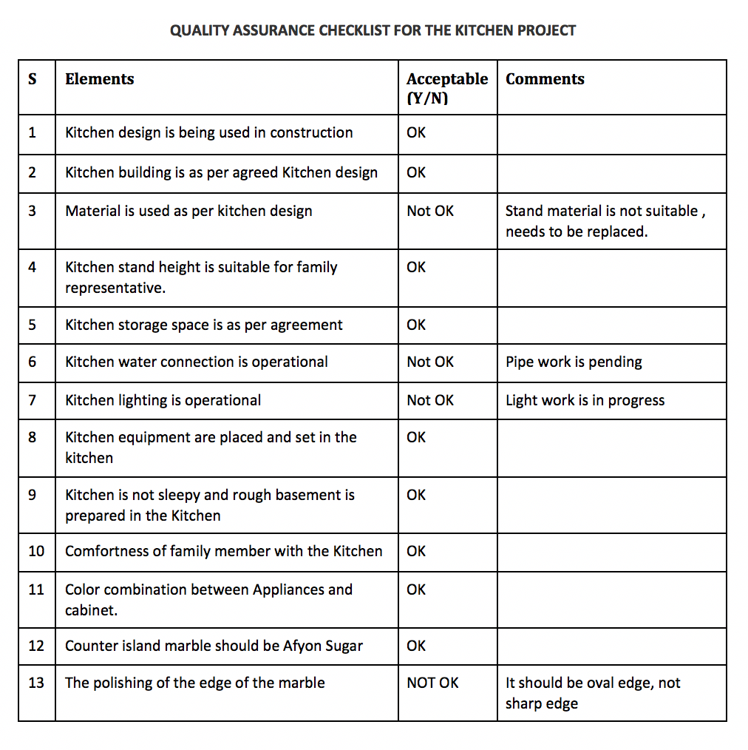

1. Develop QA checklist and completed the test.

See above example.

1. 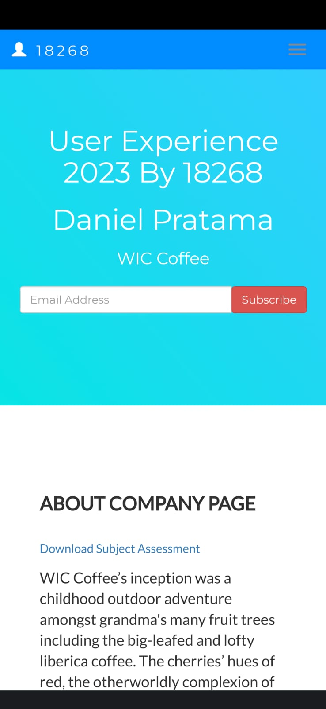Conduct QA testing and completed the check list.   
   See above example…

# Task 8

Organize documentation for all the above-mentioned tasks with screen shots or evidence photo (if applicable) and prepare a report following a report writing standard to submit to your trainer.

My site is responsive, so you could view by mobile phone version:

Please browser my site:

<https://danielpratama18.github.io/Ux012023by18268/>

# Index

B

business requirement 3

D

Develop WIC Café 4

distancing regulation 2

G

Google form 5

W

WIC Café website 3

WIC Coffee’s 2